Allies for Racial Justice During the Boston Busing/ Desegregation Crisis
Community Church of Boston
5/7/2012

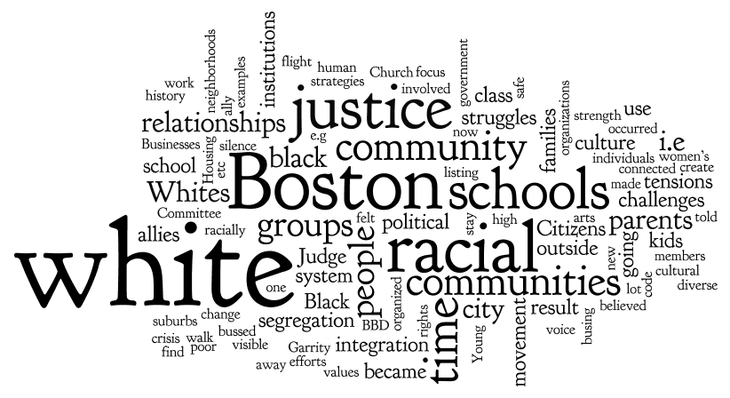

- What were the challenges, struggles, strategies and strength of white people who believed in racial justice in Boston leading up to this time?

Some examples of challenges and struggles were:
- Cities were highly segregated
- Police department faced challenges
- Black individuals were killed, and we did not know why
- Businesses moved out and Roxbury de-industrialized
- Class tensions amongst white people occurred
- Classism occurred putting the white between Blacks, which prevented class coalition
- Middle class backed away
- Ideas were challenged; should I expose my child based on my principals?
- There was no white leadership from the liberal community
- Metco should have been a two way program, because Black children were bused out, but white were not bussed in
- There were struggles because of basic human rights
- Messages were being given that Whites weren’t safe in Boston
- If you were for racial justice you were labeled as a communist
- Fear of culture mix
- Death threats for those that were involved in racial justice
- Isolation in own neighborhood
- Lack of knowledge with what was going on
- Ignorance
- No crossing boundaries (stay in your own neighborhoods)
- Poor treatment of immigrants
- Population feared reaction to busing
- Organized segregation and redlining
- Cultural segregation
- Employment barriers, skilled jobs, and union fed fears
- Counter Intelligence Program FBI (Cointell Pro)

Some examples of strategies or strengths were:
- Return from Vietnam
- Black panthers
- Irish catholic politicians
- Clergy
- Defend friendship
- Individuals worked to elect members to the school committee
- Political activism

* Questions posed in relation to this question were the following:
- How did individuals connected with one another, find each other, and discussed prior events?
- Who were Non-profit organizations helping are they a plus or a minus? And if so how were they?

- What was the state of relationships between white allies for racial justice and the various communities of greater Boston? What history had shaped these relationships?
- Residential Patterns
  - banks/government fostering segregation
  - Redlining – community tensions as integration happened
  - White flight – suburbs isolated themselves, saw TV and believed it
  - Fair housing groups in surrounding communities
  - Segregation visible on the T
- Were there real alliances?
  - Foundations, non-profits less responsibility for sustained action
  - Role of women changing – went into schools as monitors
  - One to one relationships OK, but not beyond that
  - Young people with no kids in the system
  - Outsiders, political but not attached
  - Not connected to other organizations
  - Older people with children who were political
  - Some interfaith groups
  - SDS into communities tried to listen
  - Defending families from violence
- Status of education
  - White flight
  - Debate on METCO in suburbs – deliberate isolation
  - Whites started own schools
  - Inner city schools closed, outside schools kept open so white kids didn’t have to be bussed
  - Feeling of betrayal – parents who supported busing walked away people talked the talk of supporting busing but didn’t walk the walk
  - Whites blaming families and cities for their problems

- How were white allies for racial justice interacting with local institutions (school, government, business and finance, etc.)? (e.g. How were they positioned both inside and outside these institutions?) What history was this grounded in?
Given the constraints of time, we concentrated on both listening to stories and creating a listing. The listing was an effort to name and create an accounting of organized groups or institutions relevant to white ally efforts. They included:
- Alternative high schools (i.e. Bancroft)
- Mayor
- City Council
- Churches (i.e. Trinity Church and Sam Tyler, Episcopal Diocese and Ed Rodman)
- Businesses
- The Boston Globe
- Citizens groups for community restructuring of high schools. (i.e. magnet, choices, concerted efforts to maintain racial balance)
- Legal community (i.e. NAACP, LCCR, BPS legal reps, court appointed attys (Hale & Dorr)
- Mary Ann Hardenberg’s group (Citizens for Public Schools?)
- Housing associations
- Neighborhood groups
- Citywide Education Coalition
- Citizens Against Racism
- Ad Hoc Committee for Prison Reform
- League of Women Voters

Key Comments: The language we use now was not in use then. For example: white ally, which several contributors noted didn’t exist. Anti-racism was used more literally, and not as much in the social justice context that we use now. “For integration” or “for racial justice” terms were more in vogue, with a very specific focus on the schools.
Context of the white supporters work at that time: More focus on community mental health issues, the women’s movement, integration of age and ethnicity. Commitments to be in racially diverse communities, not just racially diverse schools.
- What was happening culturally in Boston’s communities during that time period (e.g values, politics, arts, families, class, etc.)? Where did white allies for racial justice fit into this?
- At that time, Boston only thought black and white. The Latino and Asian communities became visible as a result of the BBD process.
- It was a dynamic time re: human rights – the women’s movement, a lot of change going on and dynamics about the changes so many cultural norms being tested.
- I was told as a new (POC) teacher that, if I wanted a job (go to the top of the list) I would have to pay $500. Judge Garrity ruled that we all be hired and made permanent. It was really a patronage system before Judge Garrity’s ruling…I was told I didn’t have to do lesson plans. This was gaming the system.
- Boston was a very poor city. It was inbred.
- A lot of change going on in the city involved student voice that was prominent in the movement. Judge Garrity amplified parents’ voice. He knew that for this to work, there were no elected black and brown School Committee members.
- Young people felt the Catholic Church was absent. They missed us with values that they didn’t practice during this crisis.
- There was an awakening in the black community around the whole issue of race in Boston. With the advent of the BBD crisis, the racial tensions exploded and everyone became awake and no longer felt safe outside our neighborhoods.
- It was a time of growing fear. Instead of progress being made, there was a reversal. The friendships and relationships that we had developed across racial lines in school disappeared.
- There was a group of white parents in Brighton who were preaching parent empowerment and they began training younger white parents. They were called “Communists” to discredit them.
- In the arts, Boston kids didn’t get tickets to youth concerts. They stopped it.
- A play was done. “It’s not the bus.”
- In East Boston there was cultural tension between Puerto Ricans moving into the projects. It became a big deal as a result of bussing. Politicians fanned the flames for their own political ambitions. (Pixie Palladino) As a result black families were firebombed and targeted.
- There were competing reactions
- There was a culture of “othering” with the police force. The targets shifted from Jews to blacks but the institution remained the same.
- There was the white gang war – the culture of organized crime – South Boston – you had a true code of silence to stay alive. Also a huge code of silence in suburbia. The Federal government was supporting Whitey Bulger – he was running the city.
- College campuses emphasized courses of criminal justice to attract poor white folks to become cops to legitimatize the new Jim Crow.

