The Boston Busing Desegregation Crisis and the Asian Community
Boston Chinatown Neighborhood Center
5/29/2012
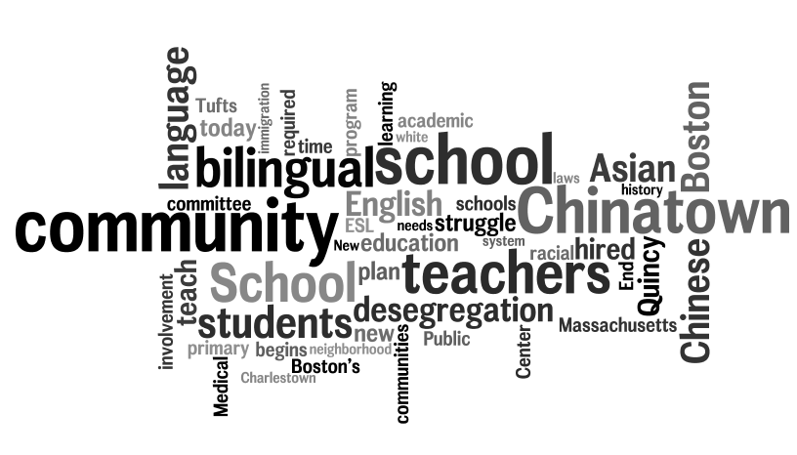
What were the challenges, struggles, strategies, and strengths of Boston’s Asian communities leading up to this time?
  - 1965 – change in immigration laws – influx in immigrants from China with limited English
  - 1966 – Boston is funded to plan a replacement for the old Quincy School. New school will be a community school, but no one in the Chinatown community is informed of the project.
- 1969 – The Chinatown community demands and begins its involvement in the planning of the new neighborhood school. Activists from Chinatown, the South End and Bay Village, planners from Tufts University and Tufts Medical Center (then the New England Medical Center), along with Boston Public School teachers and administrators, struggle to achieve a plan that respects the input of all segments of the school community
- 1970 – The Boston Public Schools recognizes the needs of new immigrant students from Hong Kong due to family reunification following changes to U.S. immigration laws. Ethnic Chinese teachers are trained and hired to teach ESL to this population.
- 1971 - Massachusetts enacts a law mandating bilingual education for up to three years when there were twenty or more English language learners of any language classification. The primary goal is to teach English while students are learning the required grade level academic content through their primary language. More ESL teachers are hired. In addition, bilingual (Cantonese/English) teachers are hired to teach various academic subjects. Most Asian American teachers in the Boston School system are in the bilingual program.
- 1974 – School desegregation by busing begins. Students from Chinatown are bused to the North End, Brighton, and Charlestown to balance racial quotas required by the racial desegregation plan. School assignment often hinges on whether or not a student is in the bilingual program.
- 1976 – The new Quincy School opens. Limited seating for neighborhood children. Was faught for as a community school, then desegregation happened and that was lost
- 1995 – Academy of the Pacific Rim is chartered; opens in 1997.
- 1999 – Quincy Upper School opens as pilot school.
- 2002 – Massachusetts decides against the continuation of bilingual education programs, emphasizing English language learning instead.
- Quincy school was a center of the community – everybody knows everybody

What was the state of relationships between Boston’s Asian communities and other ommunities of Greater Boston? What history had shaped those relationships?
- 1974 – School desegregation by busing begins. Students from Chinatown are bused to the North End, Brighton, and Charlestown to balance racial quotas required by the racial desegregation plan. School assignment often hinges on whether or not a student is in the bilingual program.
- Chinese press wasn’t covering deseg controversy; many arents don’t know what is happening outside of the community
- Students assigned to two elementary schools in Chinatown
- Summer before they were supposed to go, two Chinese young people accused of stabbing a oung white person
- Conflct between Asian and Black teachers and white teachers in Charlestown over how they were treating the stdents, took a long time
- Chinese and Latino students treated as other – both by the system and in the city generally
- Race relations shaped forever in the ity; today neighbors can be people who threw rocks there’s no way to deal with that
- Sill racially motivated violence against Asians

How were Boston’s Asian communities interacting with local institutions (school, government, business and finance, etc.)? (e.g. How were they positioned both inside and outside these institutions?) What history was this grounded in?
  - 1969 – The Chinatown community demands and begins its involvement in the planning of the new neighborhood school. Activists from Chinatown, the South End and Bay Village, planners from Tufts University and Tufts Medical Center (then the New England Medical Center), along with Boston Public School teachers and administrators, struggle to achieve a plan that respects the input of all segments of the school community
- 1970 – The Boston Public Schools recognizes the needs of new immigrant students from Hong Kong due to family reunification following changes to U.S. immigration laws. Ethnic Chinese teachers are trained and hired to teach ESL to this population.
- 1971 - Massachusetts enacts a law mandating bilingual education for up to three years when there were twenty or more English language learners of any language classification. The primary goal is to teach English while students are learning the required grade level academic content through their primary language. More ESL teachers are hired. In addition, bilingual (Cantonese/English) teachers are hired to teach various academic subjects. Most Asian American teachers in the Boston School system are in the bilingual program.
- 2002 – Massachusetts decides against the continuation of bilingual education programs, emphasizing English language learning instead.
  - 1975 - Parents got together to go to school committee; weren’t listened too (when it was their turn to speak three committee members left
  - City formed a biracial committee that didn’t include Asian or Latino/a members; Justice department wanted Chinese students back in schools as ‘buffers’
  - Lack of cultural competence in the schools got in trouble for speaking Chinese

What was happening culturally in Boston’s Asian communities during that time period? (e.g. values, politics, arts, families and neighborhoods, class, etc.)
- Tight knit community with Quincy school as a central part
- Woman standing up – were told by men and traditional organizations in the community that they couldn’t make change
- Chinese students were ‘othered’, had to choose between black or white

Connections to today:
- There was desegregation, but at a cost: many feel there was a loss of tight knit community, especially with the school at the center of that
- People who went through desegregation struggle with putting their kids in the BPS today, have a hard time trusting their kids will get a quality education
- There is still a struggle to meet the needs of ELL students, but there is less community activism like that which formed bilingual schools like the Quincy or the Hernandez in the late 1960s and 1970s
- Issues of race and class persist in the city/education today. Racism and segregation still exist but aren’t on the table for discussion; Principals struggle to leverage middleclass resources for the benefit of all students
- People from outside the city don’t grasp how this history matters
- Parental involvement is even more difficult because parents then could turn to Judge Garrity, but don’t necessarily feel they can rely on he school committee today when they have a problem
- Major theme: the intersection of policy word, community involvement and issues of race and class; Today we are so besieged by policy struggles from national forces that it is difficult to have these conversations about community and engagement

